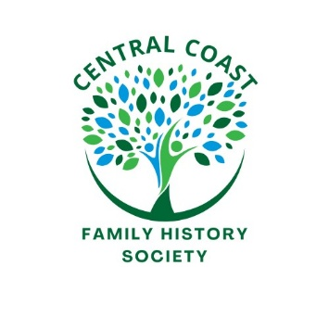***Central Coast Family History Society***

**Bookshop List**

The Following Titles are available to purchased from the Central Coast Family History Society. Please contact the society on 02 4324 5164 or use the order form on the website [www.centralcoastfhs.org.au](http://www.centralcoastfhs.org.au)

*USB price available on request*

|  |  |  |  |
| --- | --- | --- | --- |
| Back to Bourke, Courthouse Records | $70.00 | Manildra District Cemeteries – Including Cumnock & Yeoval | $40.00 |
| Brady’s Gully | $10.00 | Molong Cemetery | $40.00 |
| Brewarrina on the Barwon River | $50.00 | Moree on the Mehi | $50.00 |
| Canowindra General Cemetery | $25.00 | Narrabri on the Namoi | $50.00 |
| Cemeteries of Gresford & surrounding Districts | $25.00 | Outback Burials | $50.00 |
| Cargo - Cudal | $40.00 | Paterson Cemetery | $25.00 |
| Clarence Town General Cemetery | $25.00 | Point Clare Cemetery – General Lawn, Sections 4 & 5 | $15.00 |
| Come by Chance and Goangra | $15.00 | Point Clare Cemetery – Section 7 | $15.00 |
| Coonabarabran General Cemetery | $40.00 | Point Clare Cemetery – Section 8 | $15.00 |
| Dungog General Cemetery Vol 1. 2nd ed | $25.00 | Point Clare Cemetery – Baptist, 7th Day Adventist, Presbyterian, Methodist | $20.00 |
| Dungog General Cemetery Vol 2. 2nd ed | $25.00 | Point Frederick Pioneer Park: Lives of the Pioneers | $75.00 |
| Eugowra General Cemetery | $25.00 | Publican’s Licences, Brisbane Water 1839-1860 | $10.00 |
| From the Mountains to the Marshes | $50.00 | They Stopped a While in Come By Chance, Vol 1. | $30.00 |
| Gosford Hotels 1841 - 1921 | $15.00 | They Stopped a While in Come By Chance, Vol 2. | $30.00 |
| Graves of the Pioneers of the William & Paterson River Valley | $25.00 | They Stopped a While in Come By Chance, Vol 3. | $30.00 |
| Greengrove Cemetery (formerly Lower Mangrove Creek) | $25.00 | They Stopped a While in Come By Chance, Vol 4. | $30.00 |
| Holy Cross Cemetery, Kincumber South | $20.00 | Logan Funerals of Moree | $25.00 |
| Kincumber Remembered | $30.00 | St Thomas’ Church of England, Upper Mangrove Creek | $25.00 |
| Lisarow Cemetery Forget Us Not – Unmarked Graves (Indexed) | $50.00 | Walgett Cemetery | $50.00 |
| Lisarow Cemetery Forget Us Not – Unmarked Graves (Not Indexed) | $30.00 | Warialda on the Northern Slopes | $40.00 |
| Lisarow Cemetery Forget Us Not – Headstones | $50.00 |  |  |

